1. C Program to implement XOR operation.

#include<stdio.h>

#include<string.h>

int main()

{

char a[100],b[100],result=0;

printf("enter the value of a:");

scanf("%s",&a);

printf("enter the value of b:");

scanf("%s",&b);

for(int i=0;i<=a[i];i++)

{

if(a[i]==b[i])

printf("0");

else

printf("1");

}

}

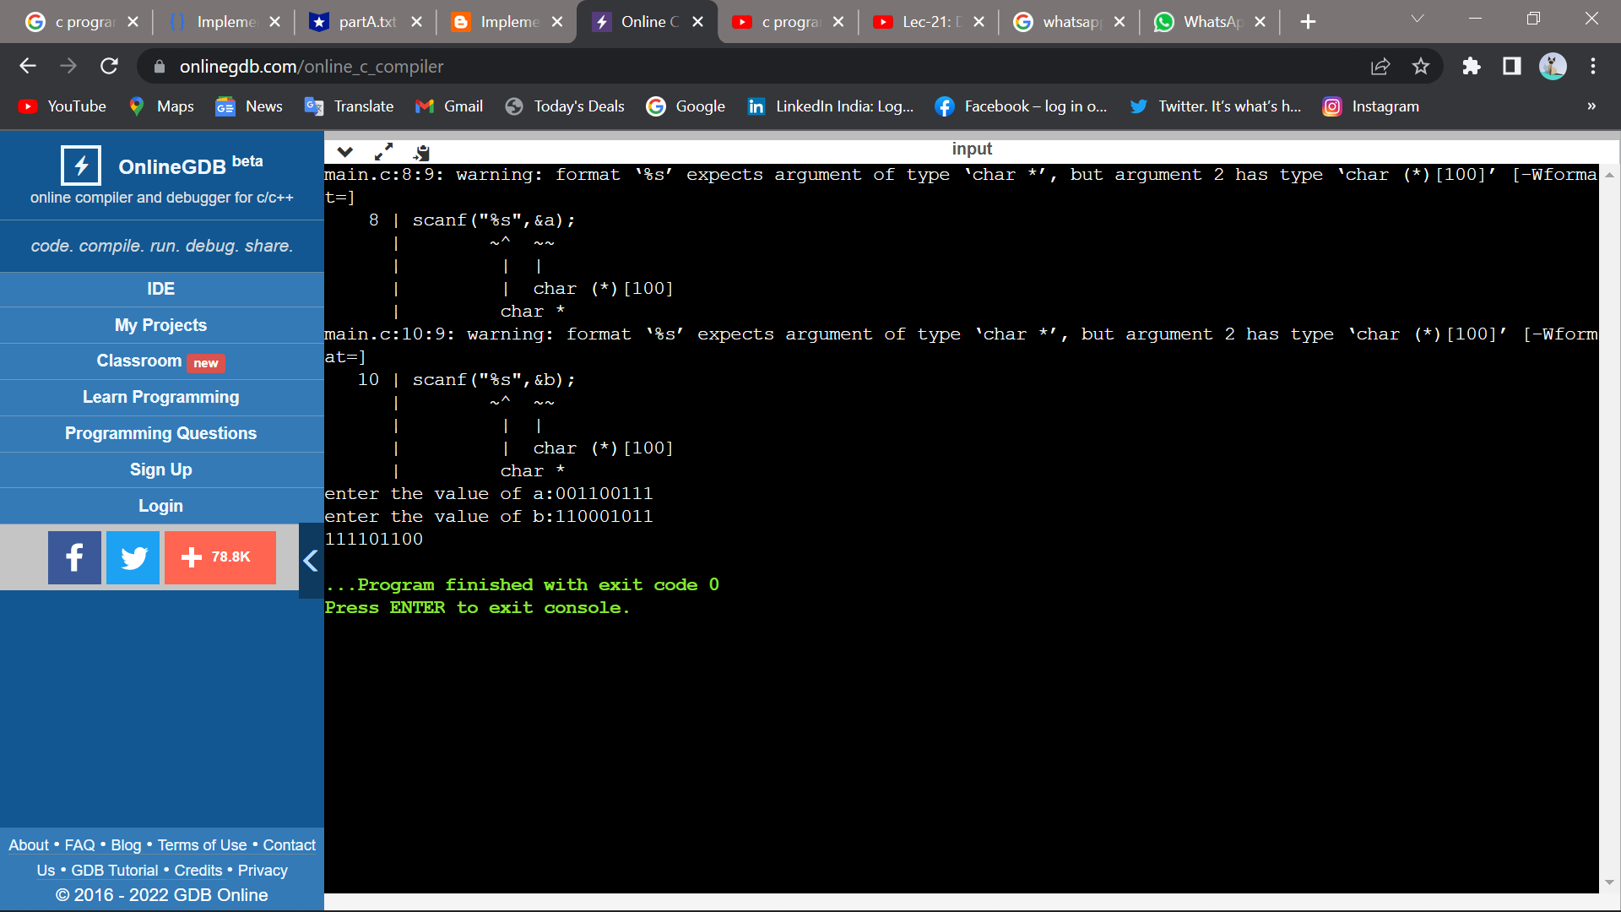

2. C Program to count the number of bits in “cprogram”.

#include<stdio.h>

#include<string.h>

int main()

{

char str[100];

int sum=0,i,n=16;

printf("enter the word :");

scanf("%s",&str);

for(i=0;i<strlen(str);i++)

{

sum=sum+n;

}

printf("the number of bits in string is %d \n",sum);

}

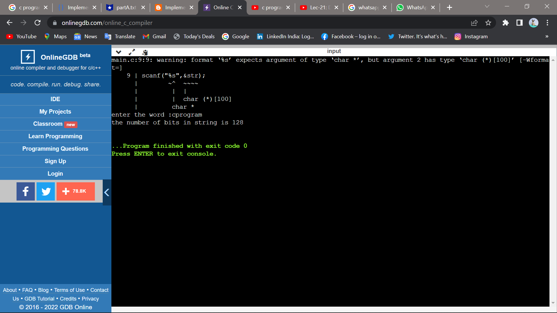

3. C Program for string searching algorithm.

#include <stdio.h>

#include <string.h>

int main()

{

char text[20],pat[20];

int a,b;

printf("Enter the string : ");

gets(text);

printf("Enter the pattern to find : ");

gets(pat);

a = strlen(pat);

b = strlen(text);

for (int i = 0; i <= b - a; i++) {

int j;

for (j = 0; j < a; j++)

if (text[i + j] != pat[j])

break;

if (j == a)

printf("Pattern found at position %d \n", i+1);

}

return 0;

}

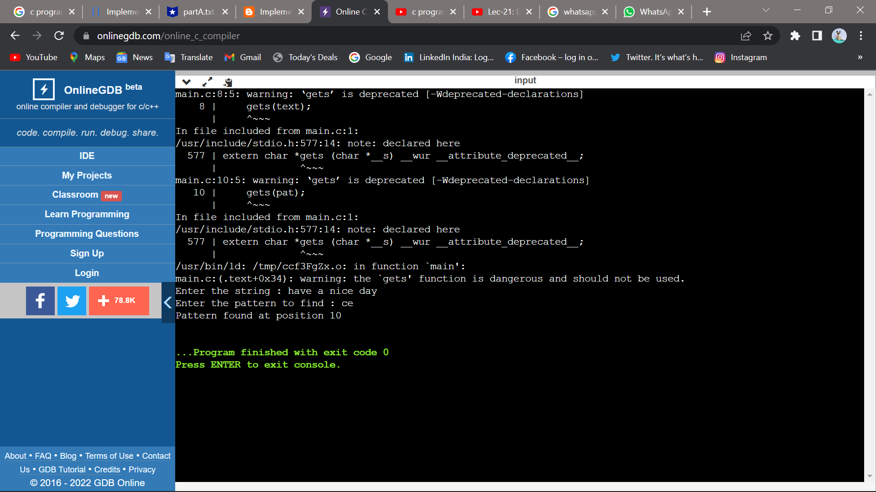

4. Design and Implement C program in which sender module should count the number of bytes in the frame and receiver module should display each frame received.

#include<string.h>

#include<stdlib.h>

char res[100];

void sender()

{

int n,i,len;

char frm[100],l[100];

printf("Enter the number of frames\n");

scanf("%d",&n);for(i=0;i<n;i++)

{

printf("Enter the frame %d\n",i+1);

scanf("%s",&frm);

len=strlen(frm);

sprintf(l,"%d",len);

strcat(l,frm);

strcat(res,l);

}

printf("The final message is %s\n",res);

}

void receiver()

{

int len,i,j;

printf("Received frame \n");

for(i=0;i<strlen(res);i++)

{

len=res[i]-'0';

for(j=i+1;j<=(i+len);j++)

printf("%c",res[j]);

i=i+len;

printf("\n");

}

}

void main()

{

sender();

receiver();

return 0;

}

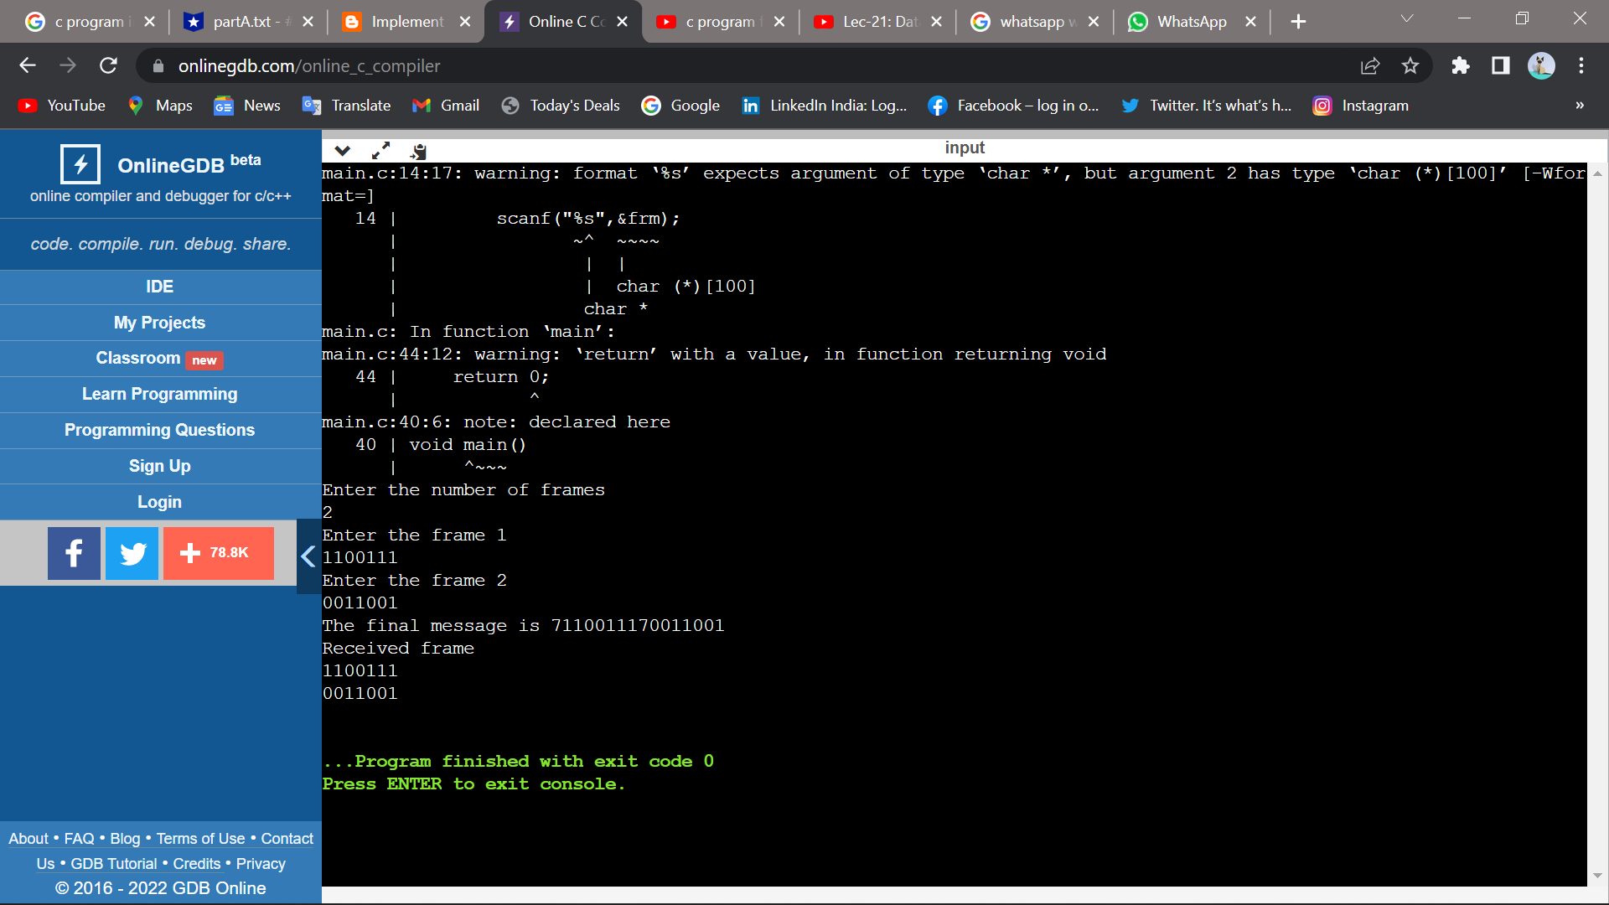

5. Design C program to implement Bit Stuffing concept in datalink layer.

#include<stdio.h>

#include<string.h>

void main()

{

int i,j,k,count=0,n;

char str[100];

printf("Enter the input frame:");

scanf("%s",&str);

for(i=0;i<strlen(str);i++)

{

count=0;

for(j=i;j<=(i+5);j++)

{

if(str[j]=='1')

{

count++;

}

}

if(count==6)

{

n=strlen(str)+2;

for(k=n;k>=(i+5);k--)

{

str[k]=str[k-1];

}

str[i+5]='0';

i=i+5;

}

}

printf("After bit stuffing the frame is:");

printf(str);

}

